AWS Elastic Load Balancer Setup with AWS SSL Certificate in EC2

**Create a domain**

* 1. In Route 53 we have to create the hosted zone for our domain (refer – Register domain documentation)

**Certificate Manager**

1. Go to Certificate Manager in AWS Console and click Request a Certificate
2. Add a domain name

Type the fully qualified domain name of the site you want to secure with an SSL/TLS certificate (for example, www.example.com). Use an asterisk (*) to request a wildcard certificate to protect several sites in the same domain. For example: *.example.com protects www.example.com, site.example.com and images.example.com.

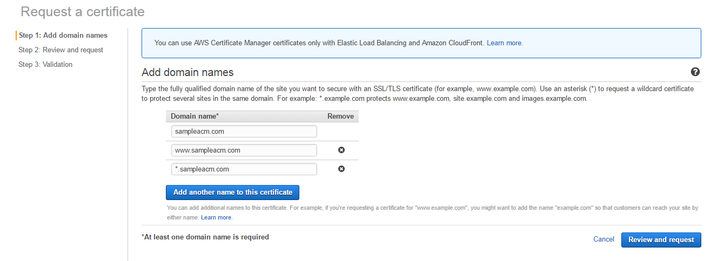

Click -> Review and Request

1. Review and Request

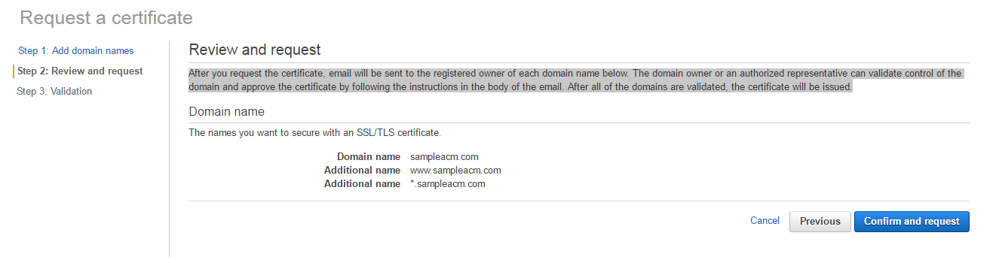

Click ->Confirm and request

1. Validation

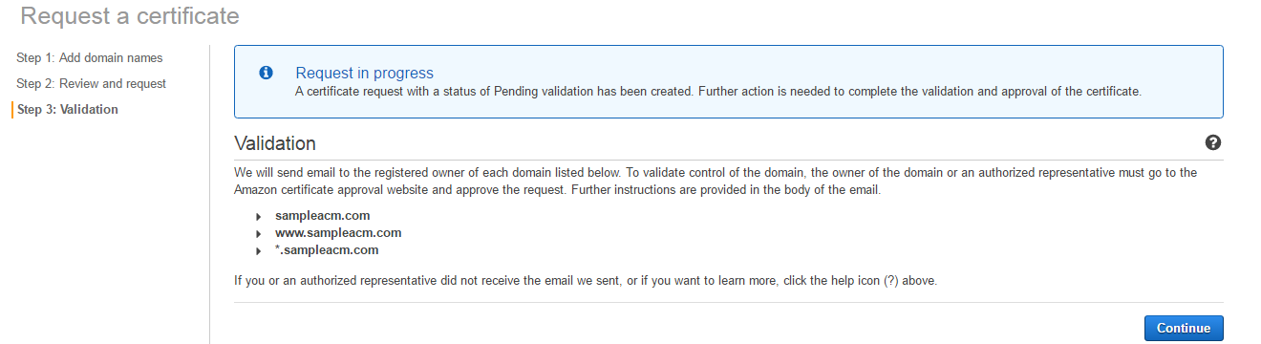

Once we click on confirm and request ,we will receive the mail .we have to validate the request by clicking the link in the mail

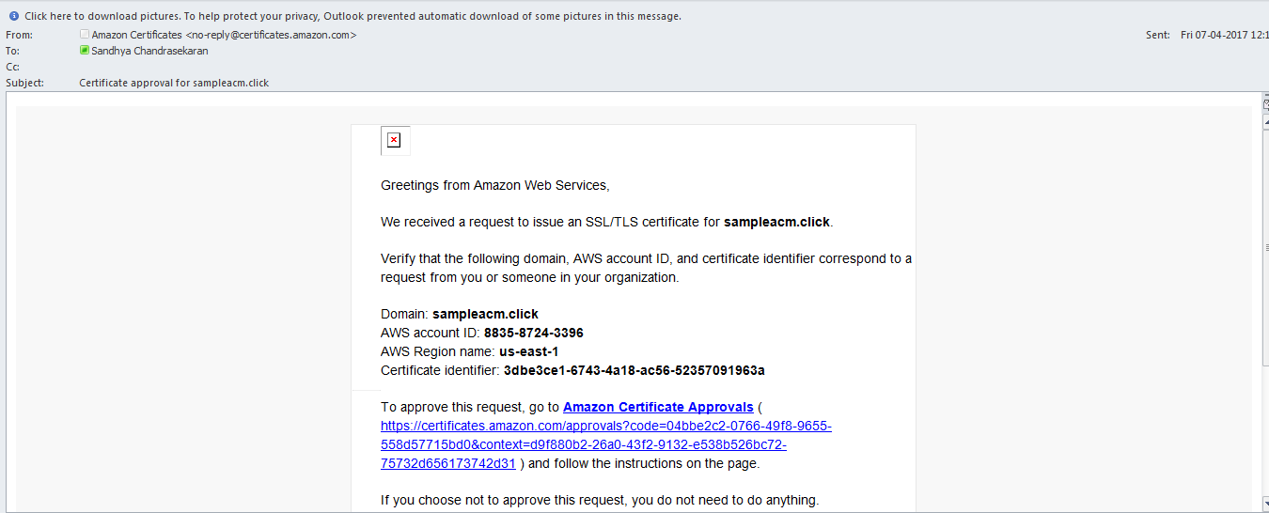

We have to click on the link

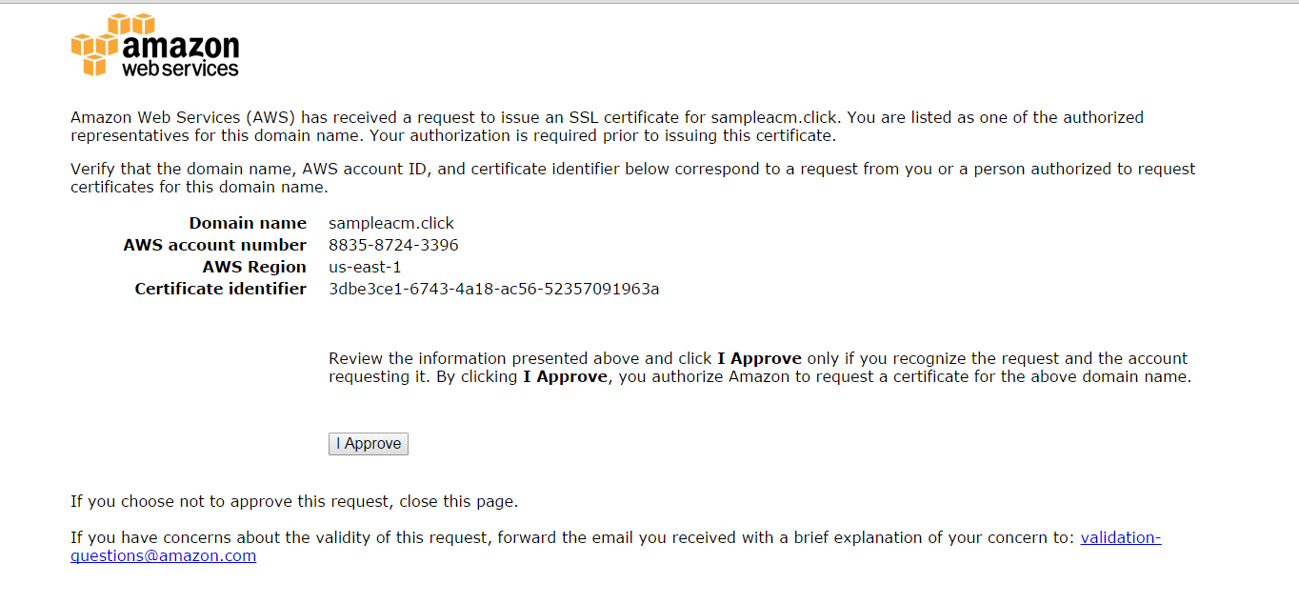

Click->I Approve

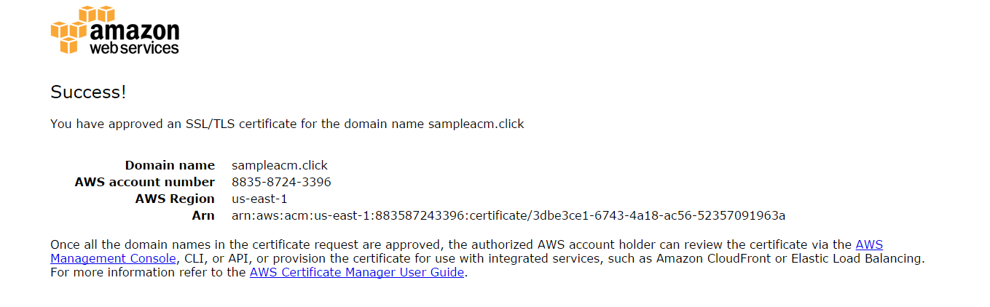

If we click on continue in AWS console,It will show as certificate issued for this particular domain

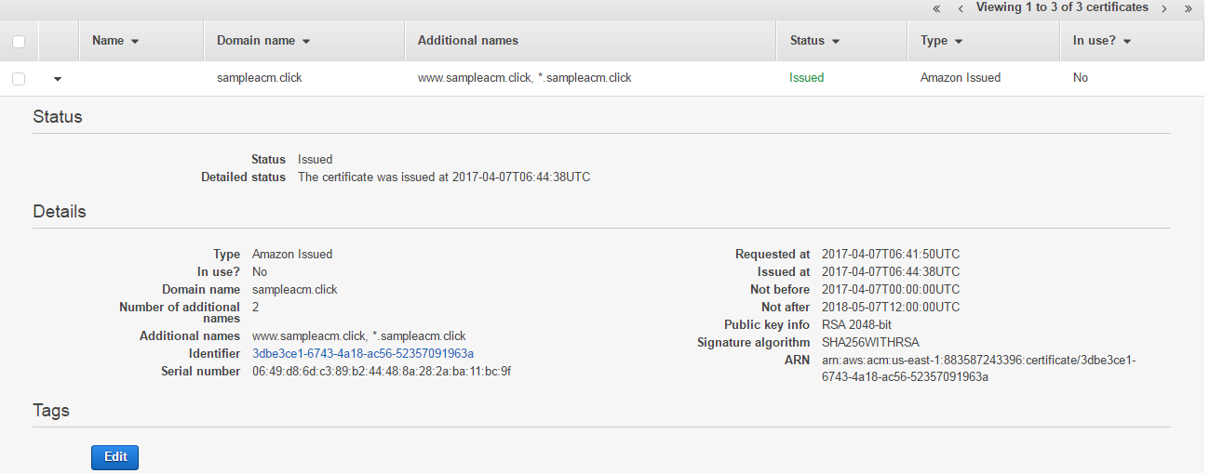

Certificate Created Successfully!!!

**Launch an Instance**

1**.**We can launch an instance(EC2) to host our application

2.Obtain Static url –Assign static IP for your instance

Once your instance is ready ,try your application in browser with the static IP of the machine

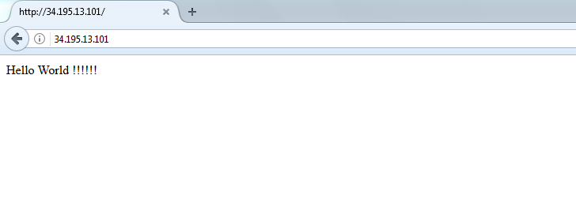

It is working!!!

**Elastic Load Balancer with Certificate Manager**

1. Launch a load balancer

Click create load balancer

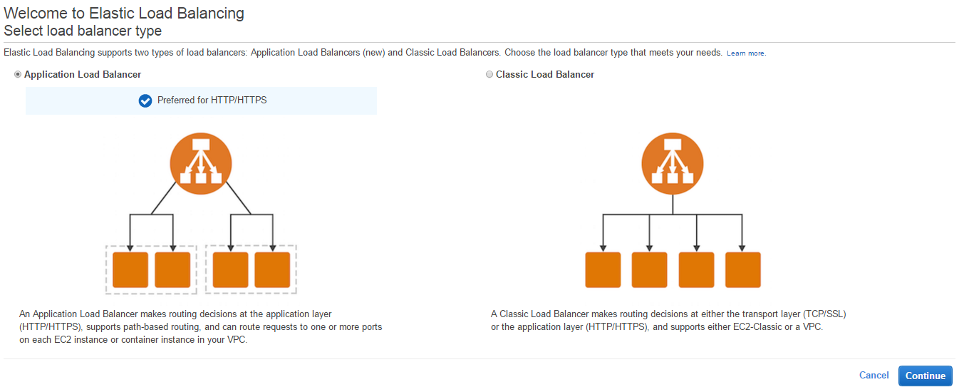

Elastic Load Balancing supports two types of load balancers: Application Load Balancers (new) and Classic Load Balancers. Choose the load balancer type that meets your needs

**Click classic load balancer->Continue**

1. Define Load Balancer

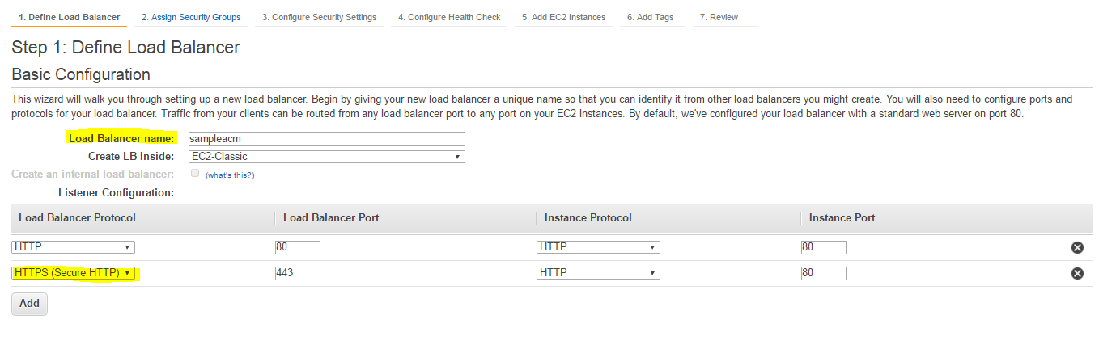

Mention load balancer name and protocol (HTTP,HTTPS)

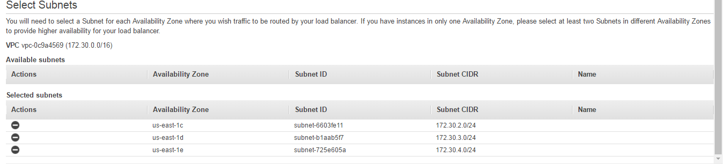Mention the subnets

1. Assign security groups

You have selected the option of having your Elastic Load Balancer inside of a VPC, which allows you to assign security groups to your load balancer. Please select the security groups to assign to this load balancer. This can be changed at any time.

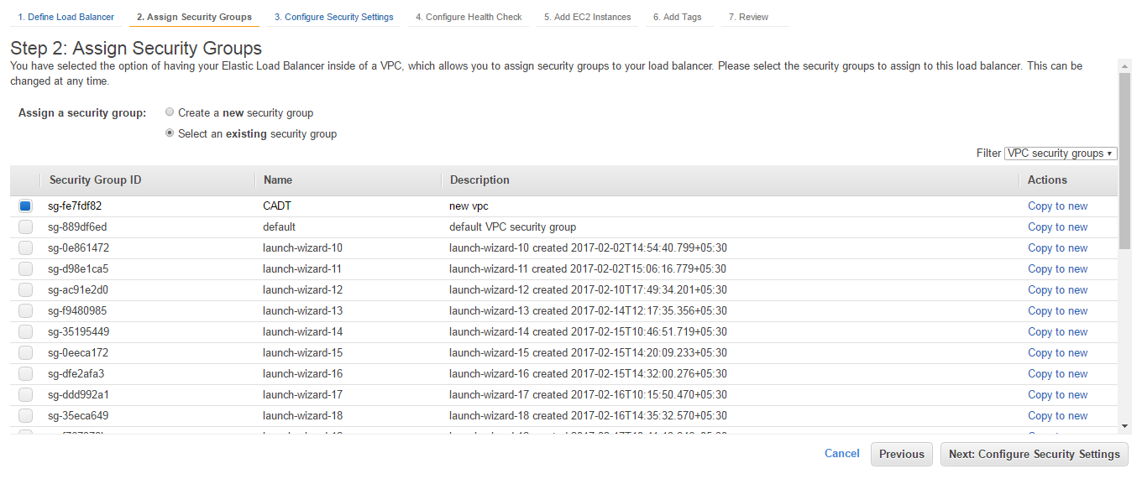

Click->next

1. Configure security groups

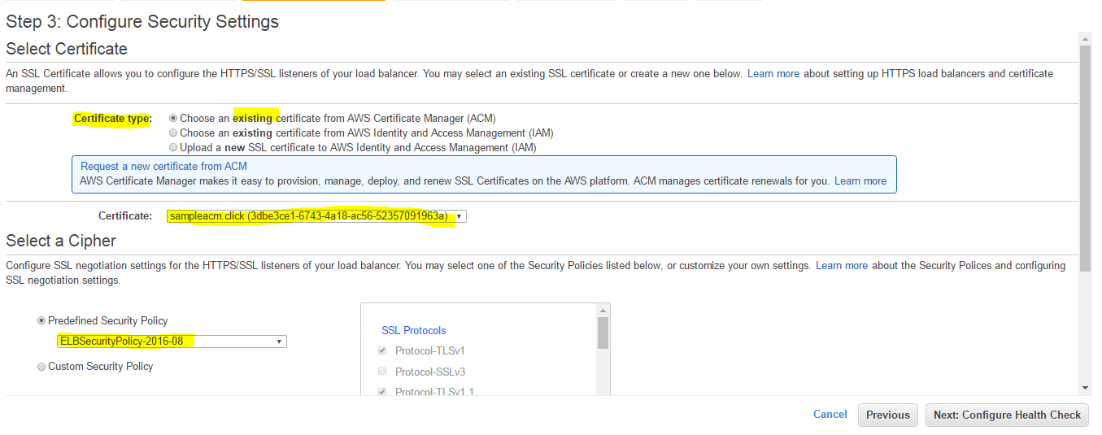

Select certificate ,choose the exiting certificate

Select a cipher,select the predefined security policy

1. Configure health check

Your load balancer will automatically perform health checks on your EC2 instances and only route traffic to instances that pass the health check. If an instance fails the health check, it is automatically removed from the load balancer. Customize the health check to meet your specific needs

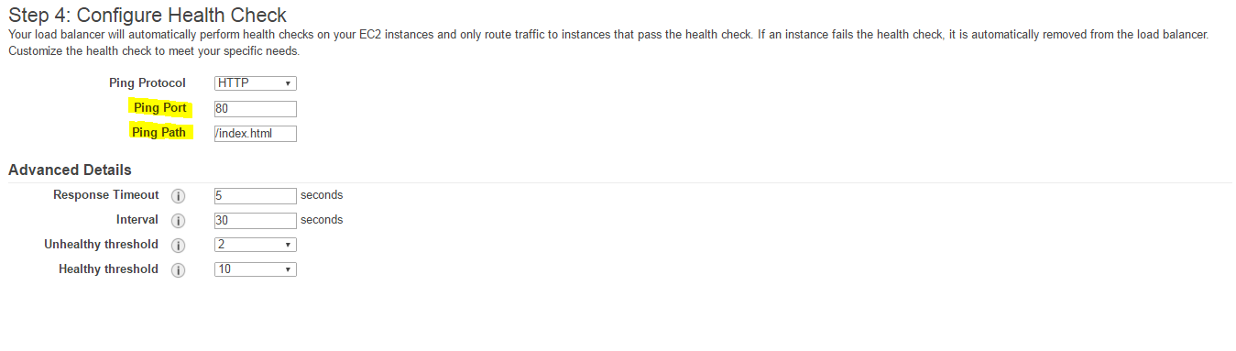

Have to mention

Ping port –In which your application is running

Ping Path –by default it will take /index.html in your application

1. Add EC2 instance

The table below lists all your running EC2 Instances. Check the boxes in the Select column to add those instances to this load balancer

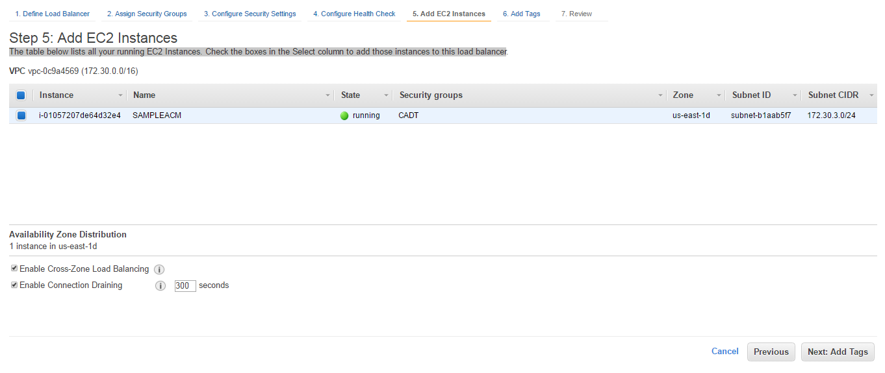

Click->next

1. Add Tags

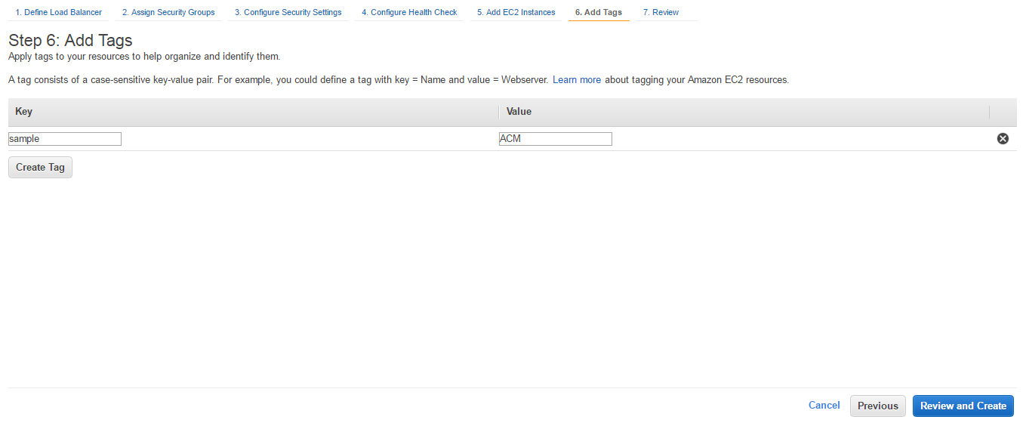

Click->review and create

1. Review

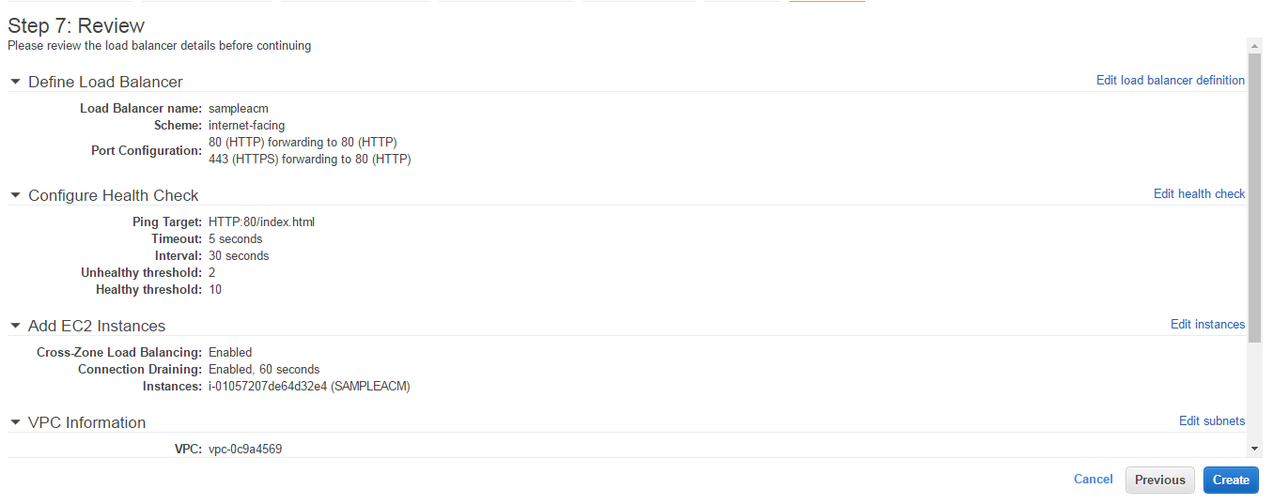

Click->create

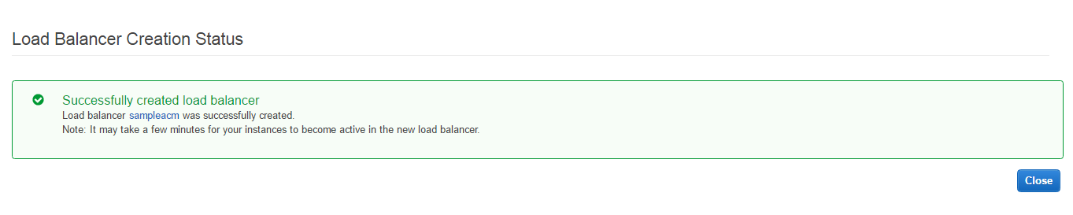

In the console

Check the instance status ,initially it would be out of service after which it became inservice

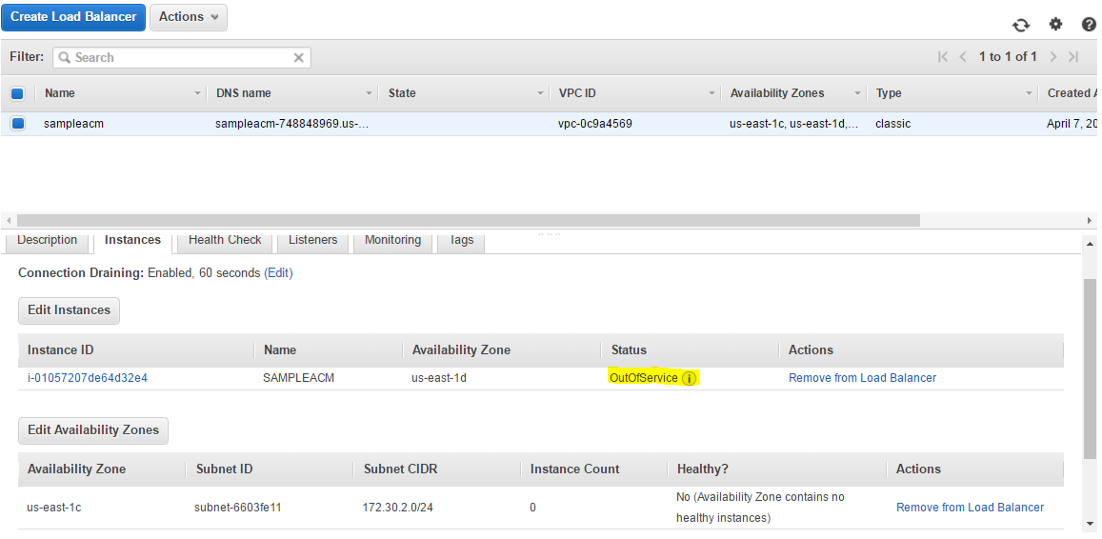

Goto ->Route 53 ->hosted zone->create record set

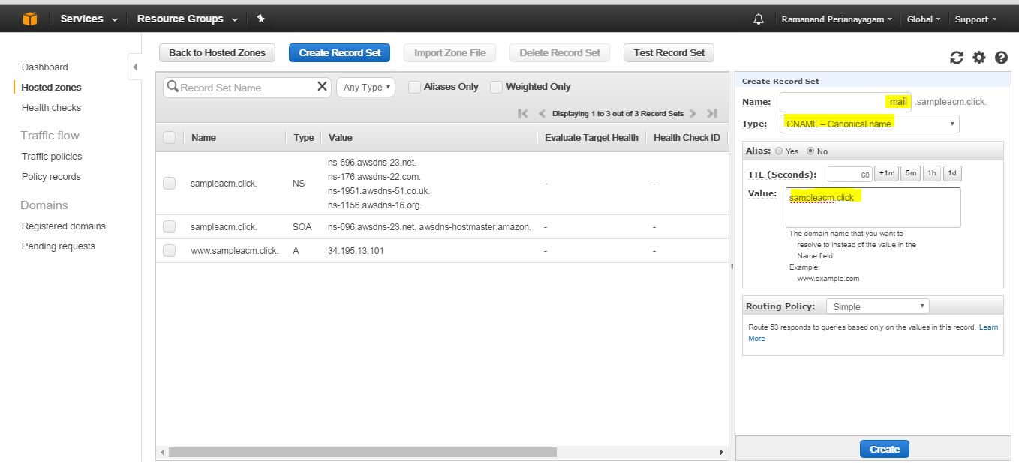

Mention the

Name –www(or) mail (or) something as mention in certificate manager

Type as CNAME

Alias –no

Value-Domain name

Now we have to forward domain to the elastic load balancer

Goto ->Route 53 ->hosted zone->create record set

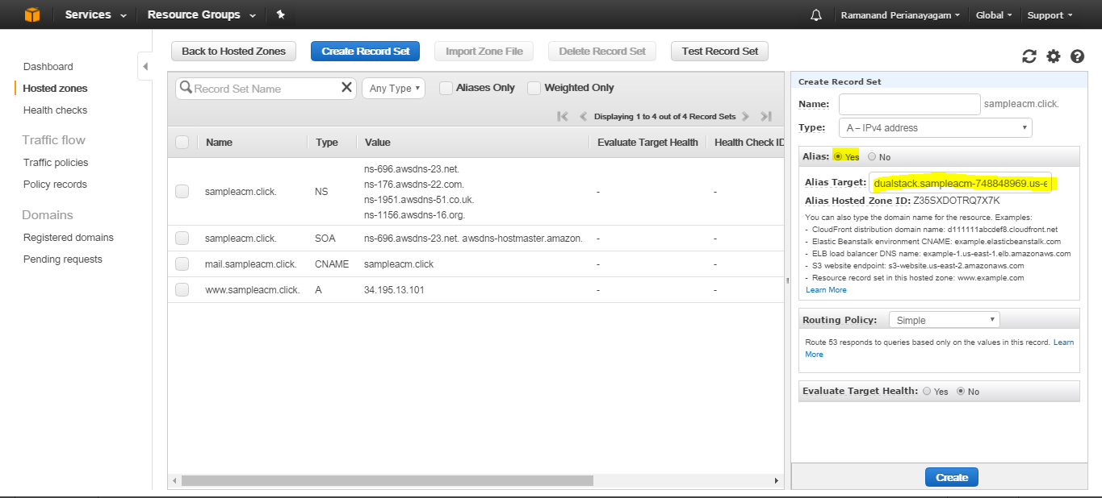

Name-should be empty

Alias – loadbalancer

Click on create

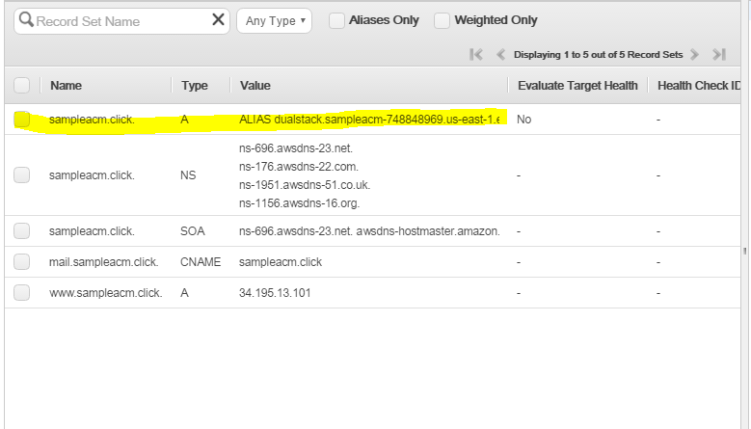

Now the domain has been forwarded to the load balancer

Once these process done, Check with the browser

Can able to check with the load balancer

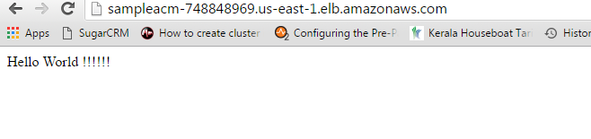

Can able to find the domain with SSL

